**Hospital Management System**

**ER Diagram**

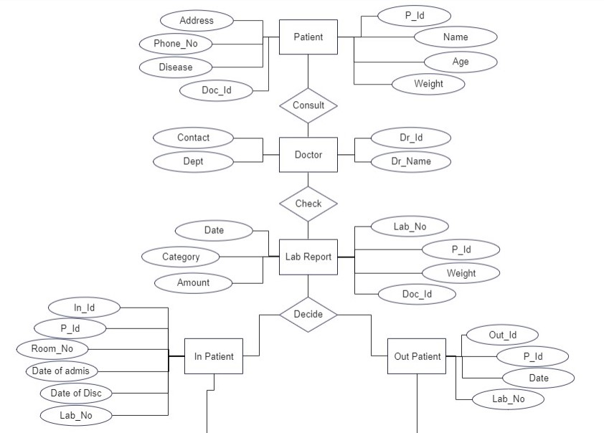

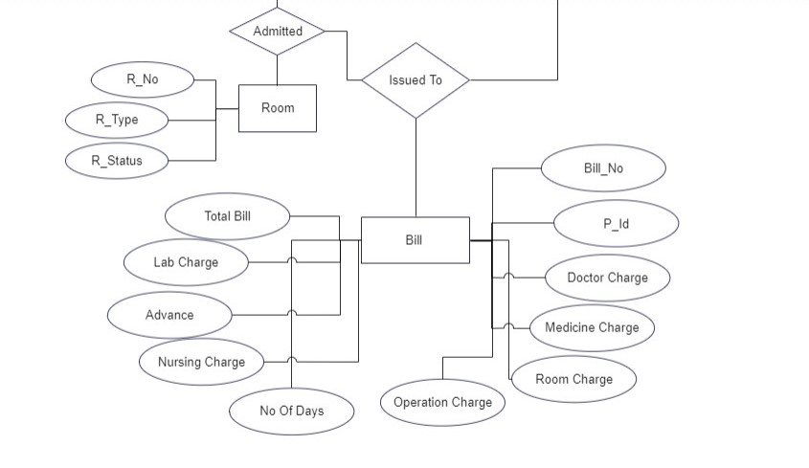

**Tables:-**

//*----------- Hospital DataBase-----------------**//

//*-----------------Creating Patient Table-----------*//

MariaDB [dbhospital]> create table pt_table(

-> P_Id varchar(5) Primary key,

-> Name varchar(20) not null,

-> Age int not null,

-> Weight int not null,

-> Gender varchar(10) not null,

-> Address varchar(30) not null,

-> Phone_No varchar(20) not null,

-> Disease varchar(30) not null,

-> Doctor_Id varchar(10) not null

-> );

Query OK, 0 rows affected (0.030 sec)

MariaDB [dbhospital]> desc pt_table;

+-----------+-------------+------+-----+---------+-------+

| Field | Type | Null | Key | Default | Extra |

+-----------+-------------+------+-----+---------+-------+

| P_Id | varchar(5) | NO | PRI | NULL | |

| Name | varchar(20) | NO | | NULL | |

| Age | int(11) | NO | | NULL | |

| Weight | int(11) | NO | | NULL | |

| Gender | varchar(10) | NO | | NULL | |

| Address | varchar(30) | NO | | NULL | |

| Phone_No | varchar(20) | NO | | NULL | |

| Disease | varchar(30) | NO | | NULL | |

| Doctor_Id | varchar(10) | NO | | NULL | |

+-----------+-------------+------+-----+---------+-------+

9 rows in set (0.020 sec)

MariaDB [dbhospital]> alter table pt_table add constraint check(P_Id >=1000);

Query OK, 0 rows affected (0.080 sec)

Records: 0 Duplicates: 0 Warnings: 0

MariaDB [dbhospital]> desc pt_table;

+-----------+-------------+------+-----+---------+-------+

| Field | Type | Null | Key | Default | Extra |

+-----------+-------------+------+-----+---------+-------+

| P_Id | varchar(5) | NO | PRI | NULL | |

| Name | varchar(20) | NO | | NULL | |

| Age | int(11) | NO | | NULL | |

| Weight | int(11) | NO | | NULL | |

| Gender | varchar(10) | NO | | NULL | |

| Address | varchar(30) | NO | | NULL | |

| Phone_No | varchar(20) | NO | | NULL | |

| Disease | varchar(30) | NO | | NULL | |

| Doctor_Id | varchar(10) | NO | | NULL | |

+-----------+-------------+------+-----+---------+-------+

9 rows in set (0.022 sec)

MariaDB [dbhospital]>

MariaDB [dbhospital]> select * from pt_table;

+------+----------+-----+--------+--------+----------+------------+-----------------+-----------+

| P_Id | Name | Age | Weight | Gender | Address | Phone_No | Disease | Doctor_Id |

+------+----------+-----+--------+--------+----------+------------+-----------------+-----------+

| 1001 | Savita | 45 | 90 | F | Badlapur | 956146255 | Thyroid | 101 |

| 1002 | Swati | 22 | 75 | F | Badlapur | 95951255 | Fungal | 102 |

| 1003 | Rahul | 25 | 65 | M | Thane | 8215951255 | Eye Check | 103 |

| 1004 | Mahesh S | 55 | 88 | M | Mumbai | 851221962 | Bone Crack | 104 |

| 1005 | Anjali | 30 | 72 | F | Andheri | 95564235 | Fever | 104 |

| 1006 | Suresh | 32 | 77 | M | Thane | 832512511 | Common Flu | 105 |

| 1007 | Prasad | 28 | 82 | M | Kalyan | 9123475622 | Teeth Replace | 106 |

| 1008 | Sneha | 33 | 86 | F | Borivali | 96214562 | Root Cannel | 106 |

| 1009 | Vijay | 65 | 76 | F | Colaba | 784623145 | Lever Operation | 107 |

| 1010 | Sahil | 79 | 85 | M | Mumbra | 796545123 | Heart Operation | 107 |

+------+----------+-----+--------+--------+----------+------------+-----------------+-----------+

10 rows in set (0.000 sec)

//*-------Creating Doctor Table---------------*//

MariaDB [dbhospital]> create table Dr_table(

-> Dr_Id int primary key check(Dr_Id >= 101),

-> Dr_Name varchar(30) not null,

-> Contact varchar(20) not null,

-> Dr_Dept varchar(30) not null

-> );

Query OK, 0 rows affected (0.040 sec)

MariaDB [dbhospital]> desc Dr_table;

+---------+-------------+------+-----+---------+-------+

| Field | Type | Null | Key | Default | Extra |

+---------+-------------+------+-----+---------+-------+

| Dr_Id | int(11) | NO | PRI | NULL | |

| Dr_Name | varchar(30) | NO | | NULL | |

| Contact | varchar(20) | NO | | NULL | |

| Dr_Dept | varchar(30) | NO | | NULL | |

+---------+-------------+------+-----+---------+-------+

4 rows in set (0.025 sec)

MariaDB [dbhospital]> select * from Dr_table;

+-------+----------------+------------+----------------------+

| Dr_Id | Dr_Name | Contact | Dr_Dept |

+-------+----------------+------------+----------------------+

| 101 | Dr.Rajendra J. | 954622812 | Thyrorid Specialist |

| 102 | Dr.Vikrant N.. | 9124826322 | Dermatologist |

| 103 | Dr. Sujay K | 823147616 | Ophthalmologist |

| 104 | Dr. Narayan S. | 7314261394 | M.B.B.S |

| 105 | Dr.M.R.Tiwari | 861321562 | General Practitioner |

| 106 | Dr.Kavita B. | 7956266192 | Dentist |

| 107 | Dr.Kailash K. | 814657946 | General Surgeon |

+-------+----------------+------------+----------------------+

7 rows in set (0.000 sec)

//*-----------------Creation Lab Tabe-------------*//

MariaDB [dbhospital]> create table Lab_table(

-> Lab_No varchar(10) primary key,

-> P_Id varchar(10) not null,

-> Weight int not null,

-> Doc_Id int,

-> Date varchar(20) not null,

-> Category varchar(20) not null,

-> Amount int not null,

-> Foreign key(Doc_Id) references Dr_table(Dr_Id)

-> );

Query OK, 0 rows affected (0.044 sec)

MariaDB [dbhospital]> desc Lab_table;

+----------+-------------+------+-----+---------+-------+

| Field | Type | Null | Key | Default | Extra |

+----------+-------------+------+-----+---------+-------+

| Lab_No | varchar(10) | NO | PRI | NULL | |

| P_Id | varchar(10) | NO | | NULL | |

| Weight | int(11) | NO | | NULL | |

| Doc_Id | int(11) | YES | MUL | NULL | |

| Date | varchar(20) | NO | | NULL | |

| Category | varchar(20) | NO | | NULL | |

| Amount | int(11) | NO | | NULL | |

+----------+-------------+------+-----+---------+-------+

7 rows in set (0.021 sec)

MariaDB [dbhospital]> select * from Lab_table;

+--------+------+--------+--------+------------+----------------------+--------+

| Lab_No | P_Id | Weight | Doc_Id | Date | Category | Amount |

+--------+------+--------+--------+------------+----------------------+--------+

| 10001 | 1001 | 90 | 101 | 2021/12/21 | Thyorid Report | 1200 |

| 10002 | 1003 | 65 | 103 | 2021/12/22 | Eye Report | 200 |

| 10003 | 1006 | 77 | 105 | 2021/12/27 | Teeth Report | 900 |

| 10004 | 1002 | 75 | 102 | 2021/12/30 | Fungal Infection Rep | 1900 |

| 10005 | 1005 | 72 | 104 | 2021/12/30 | Full Body Check | 1100 |

| 10006 | 1004 | 88 | 104 | 2021/12/31 | Bone X-Ray | 900 |

| 10007 | 1010 | 85 | 107 | 2022/1/2 | Full Heart Scan | 3900 |

| 10008 | 1008 | 86 | 106 | 2022/1/4 | Upper Jaw Scan | 800 |

| 10009 | 1007 | 82 | 106 | 2022/1/7 | Full Tooth Scan | 1200 |

| 10010 | 1009 | 76 | 107 | 2022/1/11 | Full Liver Scan | 3700 |

+--------+------+--------+--------+------------+----------------------+--------+

10 rows in set (0.000 sec)

//*--------------Creation In Patient Table------------*//

MariaDB [dbhospital]>create table InPati_table(In_Id varchar(10) primary key ,P_Id varchar(10)

,Room_No varchar(10) not null,`Date_of_Admis yyyy-mm-dd` varchar(30) not null,

`Date_of_Disc yyyy-mm-dd` varchar(30) not null, Lab_No varchar(10), foreign key(Lab_No) references Lab_table(Lab_No),

foreign key(P_Id) references pt_table(P_Id));

Query OK, 0 rows affected (0.035 sec)

+--------------------------+-------------+------+-----+---------+-------+

| Field | Type | Null | Key | Default | Extra |

+--------------------------+-------------+------+-----+---------+-------+

| In_Id | varchar(10) | NO | PRI | NULL | |

| P_Id | varchar(10) | YES | MUL | NULL | |

| Room_No | varchar(10) | NO | | NULL | |

| Date_of_Admis yyyy-mm-dd | varchar(30) | NO | | NULL | |

| Date_of_Disc yyyy-mm-dd | varchar(30) | NO | | NULL | |

| Lab_No | varchar(10) | YES | MUL | NULL | |

+--------------------------+-------------+------+-----+---------+-------+

6 rows in set (0.013 sec)

MariaDB [dbhospital]> select * from InPat_table;

+-------+------+---------+--------------------------+-------------------------+--------+

| In_Id | P_Id | Room_No | Date_of_Admis yyyy-mm-dd | Date_of_Disc yyyy-mm-dd | Lab_No |

+-------+------+---------+--------------------------+-------------------------+--------+

| 101 | 1004 | 201 | 2021/12/31 | 2022/1/2 | 10006 |

| 102 | 1009 | 203 | 2022/1/11 | 2022/2/21 | 10010 |

| 103 | 1010 | 202 | 2022/1/2 | 2022/3/3 | 10007 |

+-------+------+---------+--------------------------+-------------------------+--------+

3 rows in set (0.000 sec)

//*---------------Creation Out Patient Table ----------*//

MariaDB [dbhospital]> create table OutPat_table(Out_Id varchar(10) primary key, P_Id varchar(10),

`Date yyyy-mm-dd` varchar(20) not null,Lab_No varchar(10),foreign key(Lab_No) references Lab_table(Lab_No),

foreign key(P_Id) references pt_table(P_Id));

MariaDB [dbhospital]> desc OutPat_table;

+-----------------+-------------+------+-----+---------+-------+

| Field | Type | Null | Key | Default | Extra |

+-----------------+-------------+------+-----+---------+-------+

| Out_Id | varchar(10) | NO | PRI | NULL | |

| P_Id | varchar(10) | YES | MUL | NULL | |

| Date yyyy-mm-dd | varchar(20) | NO | | NULL | |

| Lab_No | varchar(10) | YES | MUL | NULL | |

+-----------------+-------------+------+-----+---------+-------+

4 rows in set (0.010 sec)

MariaDB [dbhospital]> select * from OutPat_table;

+--------+------+-----------------+--------+

| Out_Id | P_Id | Date yyyy-mm-dd | Lab_No |

+--------+------+-----------------+--------+

| 101 | 1001 | 2021/12/21 | 10001 |

| 102 | 1003 | 2021/12/23 | 10002 |

| 103 | 1006 | 2021/12/27 | 10003 |

| 104 | 1002 | 2021/12/30 | 10004 |

| 105 | 1005 | 2021/12/30 | 10005 |

| 106 | 1008 | 2021/1/4 | 10008 |

| 107 | 1007 | 2021/1/7 | 10009 |

+--------+------+-----------------+--------+

7 rows in set (0.000 sec)

MariaDB [dbhospital]>

//*--------------Creation Room Table----------------*//

MariaDB [dbhospital]> create table Room_table(

-> R_No varchar(10) primary key,

-> R_type varchar(30) not null,

-> R_Status varchar(3) not null

-> );

Query OK, 0 rows affected (0.038 sec)

MariaDB [dbhospital]> desc Room_table;

+----------+-------------+------+-----+---------+-------+

| Field | Type | Null | Key | Default | Extra |

+----------+-------------+------+-----+---------+-------+

| R_No | varchar(10) | NO | PRI | NULL | |

| R_type | varchar(30) | NO | | NULL | |

| R_Status | varchar(3) | NO | | NULL | |

+----------+-------------+------+-----+---------+-------+

3 rows in set (0.025 sec)

MariaDB [dbhospital]> select * from Room_table;

+------+---------------+----------+

| R_No | R_type | R_Status |

+------+---------------+----------+

| 201 | Genereal Ward | 6/10 |

| 202 | Private Room | Occupied |

| 203 | Private Room | Occupied |

| 204 | Private Room | Idle |

| 205 | Premium Room | Idle |

| 206 | General Ward | 0/12 |

+------+---------------+----------+

6 rows in set (0.000 sec)

//*----------Creation Bill Table--------------*//

MariaDB [dbhospital]> create table Bill_table( Bill_No varchar(50) primary key, P_ID varchar(10) not null, Doctor_Charge int not null, Medicine_Chargeint not null, Room_Charge int not null, Operation_Charge int, No_Of_Days int, Nursing_Charge int, Advance int, Lab_Charge int , Bill int not null );

Query OK, 0 rows affected (0.036 sec)

MariaDB [dbhospital]> desc Bill_table;

+------------------+-------------+------+-----+---------+-------+

| Field | Type | Null | Key | Default | Extra |

+------------------+-------------+------+-----+---------+-------+

| Bill_No | varchar(50) | NO | PRI | NULL | |

| P_ID | varchar(10) | NO | MUL | NULL | |

| Doctor Charge | int(11) | NO | | NULL | |

| Medicine Charge | int(11) | NO | | NULL | |

| Room Charge | int(11) | NO | | NULL | |

| Operation Charge | int(11) | YES | | NULL | |

| No Of Days | int(11) | YES | | NULL | |

| Nursing Charge | int(11) | YES | | NULL | |

| Advance | int(11) | YES | | NULL | |

| Lab Charge | int(11) | YES | | NULL | |

| Bill | int(11) | NO | | NULL | |

+------------------+-------------+------+-----+---------+-------+

11 rows in set (0.010 sec)

MariaDB [dbhospital]> insert into Bill_table values("10001","1001",600,2500,100,null,null,null,null,1200,4400);

Query OK, 1 row affected (0.010 sec)

MariaDB [dbhospital]> insert into Bill_table values("10002","1002",700,1500,100,null,null,null,null,1900,4200);

Query OK, 1 row affected (0.015 sec)

MariaDB [dbhospital]> insert into Bill_table values("10003","1003",400,1000,100,null,null,null,null,200,1700);

Query OK, 1 row affected (0.005 sec)

MariaDB [dbhospital]> insert into Bill_table values("10005","1005",600,1100,100,null,null,null,null,1100,2200);

Query OK, 1 row affected (0.005 sec)

MariaDB [dbhospital]> insert into Bill_table values("10004","1006",500,700,100,null,null,null,null,1900,3200);

Query OK, 1 row affected (0.008 sec)

MariaDB [dbhospital]> insert into Bill_table values("10006","1004",1200,2000,300,null,null,600,500,900,4500);

Query OK, 1 row affected (0.006 sec)

MariaDB [dbhospital]> insert into Bill_table values("10007","1008",2900,1500,700,null,null,900,1000,800,5800);

Query OK, 1 row affected (0.005 sec)

MariaDB [dbhospital]> insert into Bill_table values("10008","1007",4900,1400,700,null,null,1400,600,1200,9000);

Query OK, 1 row affected (0.004 sec)

MariaDB [dbhospital]> select * from Bill_table;

+---------+------+---------------+-----------------+-------------+------------------+------------+----------------+---------+------------+------+

| Bill_No | P_ID | Doctor_Charge | Medicine_Charge | Room_Charge | Operation_Charge | No_Of_Days | Nursing_Charge | Advance | Lab_Charge | Bill |

+---------+------+---------------+-----------------+-------------+------------------+------------+----------------+---------+------------+------+

| 10001 | 1001 | 600 | 2500 | 100 | 0 | 0 | 0 | 0 | 1200 | 4400 |

| 10002 | 1002 | 700 | 1500 | 100 | 0 | 0 | 0 | 0 | 1900 | 4200 |

| 10003 | 1003 | 400 | 1000 | 100 | 0 | 0 | 0 | 0 | 200 | 1700 |

| 10004 | 1006 | 500 | 700 | 100 | 0 | 0 | 0 | 0 | 1900 | 3200 |

| 10005 | 1005 | 600 | 1100 | 100 | 0 | 0 | 0 | 0 | 1100 | 2900 |

| 10006 | 1004 | 1200 | 2000 | 300 | 0 | 0 | 600 | 500 | 900 | 4500 |

| 10007 | 1008 | 2900 | 1500 | 700 | 0 | 0 | 900 | 1000 | 800 | 5800 |

| 10008 | 1007 | 4900 | 1400 | 700 | 0 | 0 | 1400 | 600 | 1200 | 9000 |

+---------+------+---------------+-----------------+-------------+------------------+------------+----------------+---------+------------+------+

8 rows in set (0.000 sec)

//*-----Bill Adding Query----*//

**Some Common Queries:**

MariaDB [dbhospital]> select Bill_No, P_ID, Doctor_Charge+Medicine_Charge+ Room_Charge+Operation_Charge+Nursing_Charge+Lab_Charge-Advance "Total Bill" from Bill_table;

+---------+------+------------+

| Bill_No | P_ID | Total Bill |

+---------+------+------------+

| 10001 | 1001 | 4400 |

| 10002 | 1002 | 4200 |

| 10003 | 1003 | 1700 |

| 10004 | 1006 | 3200 |

| 10005 | 1005 | 2900 |

| 10006 | 1004 | 4500 |

| 10007 | 1008 | 5800 |

| 10008 | 1007 | 9000 |

+---------+------+------------+

8 rows in set (0.000 sec)